AMUN CHICAGO

Travel GUIDE 2019

Welcome to Chicago, Illinois! I am so excited for an amazing week! Please have fun, make memories, and be safe! Use this travel guide as an aid while getting around and finding things to do while in Chicago!
Must have Contact Information
Travel Coordination | Ali Buzza | (608)520-9137 | travelcoordination@arizonamun.org
Sec. Gen. | Tyler Demers | (623)377-5795 | secretarygeneral@arizonamun.org
Internal Affairs | Rachel Lindzon | (602)616-4368 | internalaffairs@arizonamun.org
Rules and Procedures | Rachel Abraham | (602)770-8684 | rulesandprocedures@arizonamun.org
Perm Rep | AJ Blaine | (480)721-7742
Perm Rep | Lily Chavez | (623)606-0931
Perm Rep | Dan Acosta | (970)485-3331
Perm Rep | Koby Jargstorf | (208)602-4795
Perm Rep | Dia Agarwal | (760)464-1322
Perm Rep | Addie Lavis | (480)768-8104

-Please Don’t Hesitate to text or call anyone of the Highlighted numbers if you have any questions or problems!!

What to Bring to Chicago(Must Bring)
- School and Government issued identification (your Passport or Driver’s License, CatCard).
- Travel Documents (itineraries, boarding passes if you pre-printed them etc.)
- Mun Binder and stationary (pens, highlighters, sticky notes, note cards, loose leaf paper, etc.)
- Cell phone, laptop or tablet, flash drive and camera along with accompanying chargers
- Personal hygiene products (toothbrush, bodywash, deodorant, razor, etc.)
- Business (4) and casual attire (5), a change of shoes (business shoes, casual shoes, snow shoes, boots…etc.). Chicago will be cold, so remember to bring a thick jacket, boots, tights, scarf, hat, and gloves, umbrella, lots of socks, etc.
  - Its suppose to be around 30/40 degrees and wet! Layers will be your friend while walking around Chicago!
- Attire for themed dance (1989!!!)
- Luggage tags
- At least $50 in cash (be prepared to spend around $200),
- Snacks

Pre Departure(Arizona) Info.
Arrange to arrive at the airport at least a 1 hr and 30 mins before departure of the flight, especially if you are checking bags. Don’t forget to check-in the night before. Please meet with your flight group leader after checking your luggage so they know who arrived, and to go through security together. Double and triple check which airport you are flying out of and arriving into.

Arrival in Chicago
There are two airports that you can land in Midway(MDW) and O’Hare(ORD). After arriving in Chicago you have the option to take the train, Taxi, or Uber to the Sheraton Hotel. Whichever means of transportation you decide to take, do not take it alone. Please travel in groups and let your flight group leader know what you are doing.

Direction from Midway (MDW) to Sheraton
Train: Cost = $2.25 one-way. Travel time: 25 min ride + 15 min walk from stop to hotel.
Directions: Take the Orange Line & exit train at STATE/LAKE. See map below for directions from the train stop to the hotel.
Taxi/Uber: Cost ~ $30/person if split with a group and approx.25 min drive

Direction from O’Hare (ORD) to Sheraton
Train: Cost = $2.25 one-way. Travel time 50 mins
Directions: Take the Blue Line & exit train at CLARK/LAKE. See map below for directions from the train stop to the hotel. Only 1.2 miles or a 5 minute taxi ride away.
Taxi/Uber: Cost= $40/person 45 mins car ride

Directions from the Train Station to the Sheraton:*tip* you can also put this into your phone for GPS walking directions. It will be a 20-30 minute walk.
State and Lake:
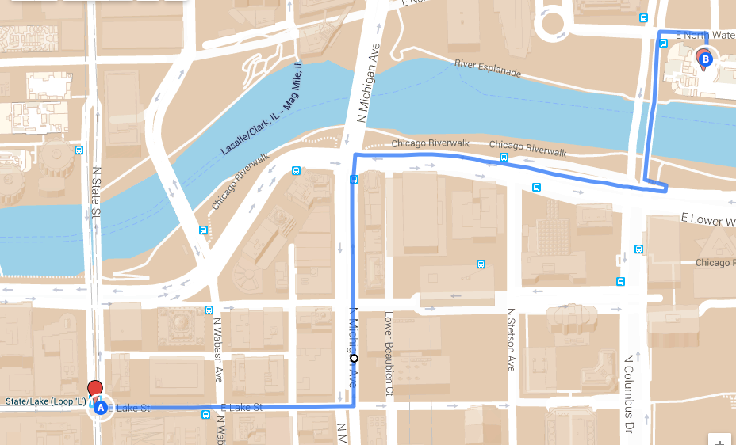

Clark and Lake:
Checking-In
You can check-in any time after 3 pm. For the flights that land early you can leave your luggage in a holding area, and explore the city until 3pm. Ali (Travelcord.) along with Tyler (Sec.Gen), will accompany you all at the front desk to ensure that there will be no charges or holds placed on your card. Do NOT give the Sheraton your credit or debit card!! Contact me if this is an issue!

Check-Out
You must check out before 11 am on Tuesday. One person from your room needs to check out and return keys. Please be looking for a message from me for further check-out instructions. Make sure that the room is somewhat tidy, and nothing is broken or misplaced. If you are staying Tuesday night(optional), but recommended, check-out will be a little different for you. If you are leaving on Tuesday right after the conference, you will leave your stuff in the following rooms that are staying an extra night.

Departing(Chicago)
Leaving Chicago will be a little different. You will be placed in to flight groups based on the time you are leaving and your final destination. If you are not placed into a flight group that means your time and destination does not match with anyone. Since it is Thanksgiving break many of you will be traveling home or going elsewhere. However, you can leave earlier to transport with someone else. Once again try to travel with at least one person or take an uber if it is early in the morning or late at night.

Conference Agenda
https://www.amun.org/agenda/

Activities
There is a lot of free time in Chicago! Use the time you have to explore and do activities/events that we may not do in Tucson. Create/ find a group to go out with and have fun! Make sure whatever you do you are back in time for committee.
$: Under $15 $$: $15-$30 $$$: above $30
Highly recommend scheduled activities:
- AZMUN Dinner: Friday, meet in the hotel lobby at 7:00 pm.
- Ice Skating: Millenium park(AZMUN outing)
- Organized outings (don’t feel obligated to go to all of these, but do take advantage of them!):

  - Chicago Museum of Contemporary Art ($$)
  - Willis Tower observatory ($$):
  - Chinatown tour/lunch ($-$$):
  - Field Museum/Shedd Aquarium/Adler Planetarium ($$ each; they’re adjacent, so might as well knock out a few a time!):
  - Christkindl Market ($-$$) dress warm, since this is an outdoor thing—but so awesome!):
  - The Bean/Art Institute ($$, bag/coat check available):
  - Navy Pier (Outdoors dress warm)
  - Jazz Night ($-$$):
  - Walking architecture tour (free!):
  - Water Tower Mall (free - $$$)
  - Old Jerusalem ($$): Rachel L’s favorite Mediterranean place :)
  - Magnificent Mile (free - $$$):

Specific Museums:
  - Museum of Science and Industry ($$-$$$)
  - Chicago History Museum ($)
  - DuSable Museum of African American History ($)
  - National Museum of Mexican Art (free, closed Monday)
  - Chicago cultural Museum
  - The Oriental institute
  - Wndr Museum (great for the insta) ($$$)

Parks(Take cute pics lol):
  - The Park at LakeShore East
  - Grant Park
  - Millenium Park
  - Maggie Daley Park

Nearby Food
- Many places Do not do separate checks so try to walk with enough cash/use venmo.
- Breakfast/Brunch
  - Eggy’s Diner $$
  - Yolk $$
  - West Egg Cafe $$
  - Wildberry (a personal favorite) $$
  - Kanela Breakfast Club $$
  - Miss Ricky’s Diner $$

- Lunch/Dinner
  - Weiner's Circle $ (they yell at you)
  - Eataly $$
  - Nandos $$
  - Pierogi Heaven $
  - Native Foods Cafe(vegan)
  - Noodles and Company
  - Greek Town
  - Cafecito
  - The Gage
  - Italian village $$
  - Dao Thai $$
  - Ramen Misoya $
  - Ryo sushi $$
  - Sushi Sai $$(All you can eat sushi)
  - Saucy Porka(Asian fusion)
  - Billy Goat Tavern(Cash only)
  - Old Jerusalem (best Mediterranean food in the city) $$

- Desserts
  - Nutella Cafe $$
  - Sugar Bliss Cake Boutique $
  - Alliance Patisserie $$
  - Firecake Donuts $
  - Ben&Jerrys $
  - Ghirardelli Ice Cream & Chocolate Shop $
  - Molly’s Cupcakes $$

- Stores for Late night Snacks
  - Target
  - Wholefoods
  - Walgreens
  - Subways
  - Mcdonalds
  - GrubHub, Postmates

Reminder
Chicago is a very large city! Please travel in groups and be aware of your surroundings at ALL times! I love you all and want you to have the best Chicago experience ever. If you ever need anything during the trip, please do not hesitate to contact me, another member of ExComm, or Perm Rep.
Xoxo,
Ali

